UNIT 5
Artificial Intelligence (AI)

5.1 AI Introduction
The humans are considered as the most intelligent species on this earth as they can solve any problem and analyze big data with their skills like analytical thinking, logical reasoning, statistical knowledge, and mathematical or computational intelligence. Keeping all these combinations of skills in mind, artificial intelligence is developed for machines and robots which impose the ability to solve complex problems in the machines as similar to those that can be done by humans.
The goals of artificial intelligence include mimicking human intellectual activity. Researchers and developers in the field are making surprisingly rapid steps in mimicking activities such as learning, reasoning, and perception, to the extent that these can be concretely defined. Some believe that innovators may soon be able to develop systems that exceed the capacity of humans to learn or reason out any subject. But others remain unconvinced because all intellectual activity is laced with value judgments that are subject to human experience. AI is continuously evolving to benefit many different industries. Machines are wired using a cross-disciplinary approach based on mathematics, computer science, psychology, and more.
Artificial intelligence (AI) refers to the simulation of human intelligence in machines that are programmed to think like humans and mimic their actions. The term may also be applied to any machine that exhibits behaviors associated with a human mind such as learning and problem-solving.
As technology advances, previous benchmarks that defined artificial intelligence become outdated. For example, machines that calculate basic functions or recognize text through optical character recognition are no longer considered to embody artificial intelligence, since this function is now taken for granted as an inherent computer function.
Fact: The first artificial intelligence is thought to be a checkers-playing computer built by Oxford University (UK) computer scientists in 1951.

5.2 Area of AI
There are main six area of AI, which are explained below:
- Machine learning
- Neural network
- Deep learning
- Natural language processing
- Cognitive computing
- Computer vision
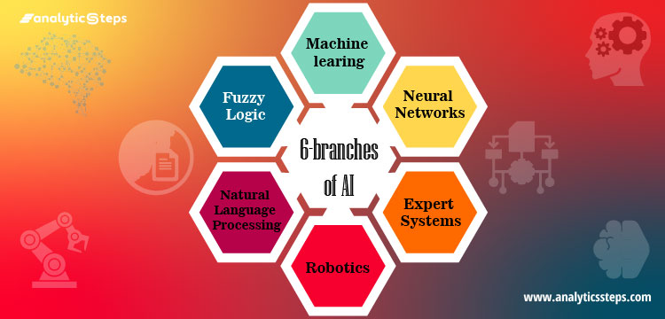
Fig: Main areas of AI

5.2.1 Machine Learning
Machine learning (ML) is defined as a discipline of artificial intelligence (AI) that provides machines the ability to automatically gather data, learn from data and past experiences to identify patterns and make predictions with minimal human intervention.
ML applications are fed with new data, and they can independently learn, grow, develop, and adapt. Machine learning derives insightful information from large volumes of data by using algorithms to identify patterns and learn in an iterative process. ML algorithms use computation methods to learn directly from data instead of relying on any predetermined equation that may serve as a model. The performance of ML algorithms adaptively improves with an increase in the number of available samples during the ‘learning’ processes.
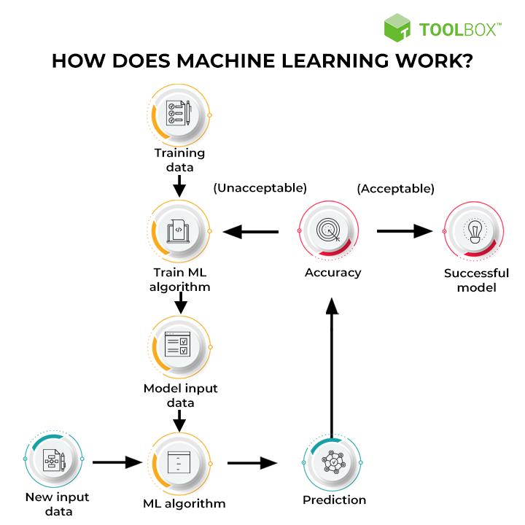
Further, the prediction is checked for accuracy. Based on its accuracy, the ML algorithm is either deployed or trained repeatedly with an augmented training dataset until the desired accuracy is achieved.
The three main types of machine learning are:
a. Supervised ML
This type of ML involves supervision, where machines are trained on labeled datasets and enabled to predict outputs based on the provided training. The labeled dataset specifies that some input and output parameters are already mapped. Hence, the machine is trained with the input and corresponding output.
For example, consider an input dataset of parrot and crow images. Initially, the machine is trained to understand the pictures, including the parrot and crow’s color, eyes, shape, and size. Post-training, an input picture of a parrot is provided, and the machine is expected to identify the object and predict the output. The trained machine checks for the various features of the object, such as color, eyes, shape, etc., in the input picture, to make a final prediction. This is the process of object identification in supervised machine learning.
b. Unsupervised machine learning
Unsupervised learning refers the machine is trained using an unlabeled dataset and is enabled to predict the output without any supervision. An unsupervised learning algorithm aims to group the unsorted dataset based on the input’s similarities, differences, and patterns.
For example, consider an input dataset of images of a fruit-filled container. Here, the images are not known to the machine learning model. When we input the dataset into the ML model, the task of the model is to identify the pattern of objects, such as color, shape, or differences seen in the input images and categorize them. Upon categorization, the machine then predicts the output as it gets tested with a test dataset.
c. Semi-supervised learning
Semi-supervised learning comprises characteristics of both supervised and unsupervised machine learning. It uses the combination of labeled and unlabeled datasets to train its algorithms. Using both types of datasets, semi-supervised learning overcomes the drawbacks of the options mentioned above.

5.2.2 Neural Network (ANN)
To understand how an artificial neuron works, we should first understand how a biological neuron works.
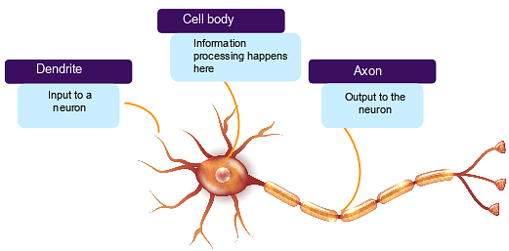
Fig: Biological Neuron
The neural network is a branch of artificial intelligence that makes use of neurology (a part of biology that concerns the nerve and nervous system of the human brain). Neural network replicates the human brain where the human brain comprises an infinite number of neurons and to code brain-neurons into a system or a machine is what the neural network functions.
In simple terms, a neural network is a set of algorithms that are used to find the elemental relationships across the bunches of data’s via the process that imitates the human brain operating process.
A neuron in a neural network is a mathematical function (such as activation functions) whose work is to gather and classify information according to a particular structure, the network strongly implements various statistical techniques, such as regression analysis, to accomplish tasks.
From forecasting to market research, they are extensively used for fraud detection, risk analysis, stock-exchange prediction, sales prediction and many more.
The image shown below depicts an ANN.
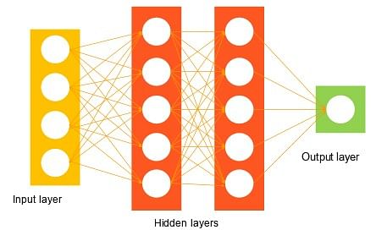
The network starts with an input layer that receives input in data form.
The lines connected to the hidden layers are called weights, and they add up on the hidden layers. Each dot in the hidden layer processes the inputs, and it puts an output into the next hidden layer and, lastly, into the output layer. Looking at the above two images, you can observe how an ANN replicates a biological neuron.

5.2.3 Robotics
This has emerged as a very sizzling field of artificial intelligence. An interesting field of research and development mainly focuses on designing and constructing robots. Robotics is an interdisciplinary field of science and engineering incorporated with mechanical engineering, electrical engineering, computer science, and many others. Robotics determines the designing, producing, operating, and usage of robots.
It deals with computer systems for their control, intelligent outcomes, and information transformation. Robots are deployed often for conducting tasks that might be laborious for humans to perform steadily. Major of robotics tasks involved- assembly line for automobile manufacturing, for moving large objects in space by NASA. AI researchers are also developing robots using machine learning to set interaction at social levels.

5.2.4 Expert Systems
Expert systems were considered amid the first successful model of AI software. For the first time, they were designed in the 1970s and after that escalated in the 1980s. Under the umbrella of an AI technology, an expert system refers to a computer system that mimics the decision-making intelligence of a human expert. It conducts this by deriving knowledge from its knowledge base by implementing reasoning and insights rules in terms with the user queries.

The effectiveness of the expert system completely relies on the expert’s knowledge accumulated in a knowledge base. The more the information collected in it, the more the system enhances its efficiency. For example, the expert system provides suggestions for spelling and errors in Google Search Engine. Expert systems are built to deal with complex problems via reasoning through the bodies of proficiency (expertise). The key features of expert systems include extremely responsive, reliable, understandable and high execution.

5.2.5 Fuzzy Logic
In the real world, sometimes we face a condition where it is difficult to recognize whether the condition is true or not, their fuzzy logic gives relevant flexibility for reasoning that leads to inaccuracies and uncertainties of any condition.

In simpler terms, Fuzzy logic is a technique that represents and modifies uncertain information by measuring the degree to which the hypothesis is correct. Fuzzy logic is also used for reasoning about naturally uncertain concepts. Fuzzy logic is convenient and flexible to implement machine learning techniques and assist in imitating human thought logically.

It is simply the generalization of the standard logic where a concept exhibits a degree of truth between 0.0 to 1.0. If the concept is completely true, standard logic is 1.0 and 0.0 for the completely false concept. But in fuzzy logic, there is also an intermediate value too which is partially true and partially false.

5.2.6 Natural Language Processing
NLP is the part of computer science and AI that can help in communicating between computer and human by natural language. It is a technique of computational processing of human languages. It enables a computer to read and understand data by mimicking human natural language.
NLP is a method that deals in searching, analyzing, understanding and deriving information from the text form of data. In order to teach computers how to extract meaningful information from the text data, NLP libraries are used by programmers. A common example of NLP is spam detection, computer algorithms can check whether an email is a junk or not by looking at the subject of a line, or text of an email.
Implementing NLP gives various benefits such as;
- It improves the accuracy and efficiency of documents.
- It has the ability to make automated readable summary text.
- It is very advantageous for personal assistants such as Alexa,
- It enables organizations to opt chatbots for customer support.
- It makes sentiment analysis easier.

Some of the NLP applications are text translation, sentiment analysis, and speech recognition. For example, Twitter uses NLP technique to filter terroristic language from various tweets, Amazon implements NLP for interpreting customer reviews and enhancing their experience.

5.3 Advantages of AI
The advantages of Artificial intelligence applications are enormous and can revolutionize any professional sector. Let’s see some of them:
1) Reduction in Human Error:
The phrase “human error” was born because humans make mistakes from time to time. Computers, however, do not make these mistakes if they are programmed properly. With Artificial intelligence, the decisions are taken from the previously gathered information applying a certain set of algorithms. So errors are reduced and the chance of reaching accuracy with a greater degree of precision is a possibility.
Example: In Weather Forecasting using AI they have reduced the majority of human error.
2) Takes risks instead of Humans:
This is one of the biggest advantages of Artificial intelligence. We can overcome many risky limitations of humans by developing an AI Robot which in turn can do the risky things for us. Let it be going to mars, defuse a bomb, explore the deepest parts of oceans, mining for coal and oil, it can be used effectively in any kind of natural or man-made disasters.
Example: Chernobyl nuclear power plant explosion in Ukraine. At that time there were no AI-powered robots that can help us to minimize the effect of radiation by controlling the fire in early stages, as any human went close to the core was dead in a matter of minutes. They eventually poured sand and boron from helicopters from a mere distance.
AI Robots can be used in such situations where intervention can be hazardous.
3) Available 24x7:
An Average human will work for 4–6 hours a day excluding the breaks. Humans are built in such a way to get some time out for refreshing themselves and get ready for a new day of work and they even have weekly offed to stay intact with their work-life and personal life. But using AI we can make machines work 24x7 without any breaks and they don’t even get bored, unlike humans.
Example: Educational Institutes and Helpline centers are getting many queries and issues which can be handled effectively using
AI. 4) Helping in Repetitive Jobs:
In our day-to-day work, we will be performing many repetitive works like sending a thanking mail, verifying certain documents for errors and many more things. Using artificial intelligence we can productively automate these boring tasks.
Example: In banks, we often see many verifications of documents to get a loan which is a repetitive task for the owner of the bank. Using AI Cognitive Automation the owner can speed up the process of verifying the documents by which both the customers and the owner will be benefited.
5) Digital Assistance:
Some of the highly advanced organizations use digital assistants to interact with users which saves the need for human resources. The digital assistants also used in many websites to provide things that users want. We can chat with them about what we are looking for. Some chatbots are designed in such a way that it’s become hard to determine that we’re chatting with a chatbot or a human being.
Example: We all know that organizations have a customer support team that needs to clarify the doubts and queries of the customers. Using AI the organizations can set up a Voice bot or Chatbot which can help customers with all their queries. We can see many organizations already started using them on their websites and mobile applications.
6) Faster Decisions:
Using AI alongside other technologies we can make machines take decisions faster than a human and carry out actions quicker. While taking a decision human will analyze many factors both emotionally and practically but AI-powered machine works on what it is programmed and delivers the results in a faster way.
Example: We all have played Chess games in Windows. It is nearly impossible to beat CPU in the hard mode because of the AI behind that game. It will take the best possible step in a very short time according to the algorithms used behind it.
7) Daily Applications:
Daily applications such as Apple’s Siri, Window’s Cortana, Google’s OK Google are frequently used in our daily routine whether it is for searching a location, taking a selfie, making a phone call, replying to a mail and many more.
Example: Around 20 years ago, when we are planning to go somewhere we used to ask a person who already went there for the directions. But now all we have to do is say Google Map where is NIC Asia Bank”. It will show you all the NIC Asia Bank location on Google map and the best path between you and the bank.
8) New Inventions:
AI is powering many inventions in almost every domain which will help humans solve the majority of complex problems.
Example: Recently doctors can predict cancer at earlier stages using advanced AI-based technologies.

5.4 Application of AI

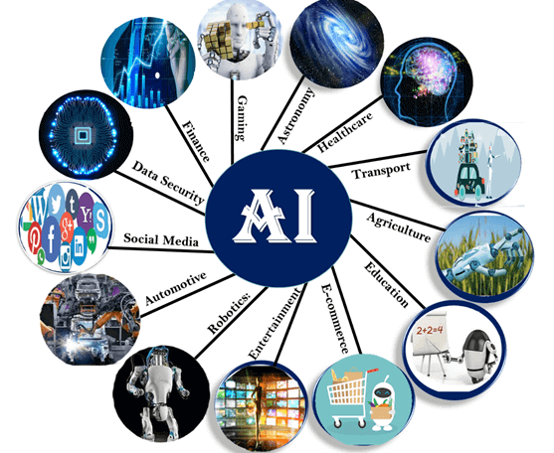

1. AI Applications in Robotics
Nowadays, robots are becoming more and more advanced and efficient in accomplishing tasks without human intervention. This is because AI tools and techniques are specially designed for the field of robotics. Advanced robots consist of sensors, high-definition cameras, voice recognition devices, etc. These robots are capable of learning from their past mistakes and experiences and adjusting the algorithms according to the environment. AI is an extremely useful tool for robotic applications. When it is combined with advanced devices, it can help in optimizations. It is helpful in enhancing the complex manufacturing process in industries such as aerospace. The packaging process in industries also uses AI to enhance productivity and lower the overall cost.
2. AI Applications in security
The manual identification and processing of unusual activities may not detect potential threats and can be time-consuming; this is where the involvement of AI proves to be of great use. The analysis of large amounts of data becomes easy with the help of AI. AI tools help in finding suspicious activity. AI algorithms are designed in such a way that they try to learn from the data and distinguish between authorized access and unauthorized access. It can be useful to keep a track of the safety of sensitive data like military databases, government databases, etc.
3. AI Applications in Transport
AI has completely transformed the transport industry. As the competition in the transport industry is high, there is a need to analyze all the factors that influence the various facets of the business. Seasons, festivals, routes, halts, and number of travelers on a route can all be reasons for these fluctuations. With the help of predictive analytics, data related to these factors, which impact the cost of transport, can be analyzed. AI tools help perform predictive analytics on data efficiently. With AI tools, the software or application can also predict the best prices for specific routes. This helps passengers find cheaper options.
Another real-life application of AI in the field of transport is in online ride-sharing services such as Uber, Lyft, and Ola. These applications use AI, machine learning (ML), and data science to deliver customized services.
4. AI Applications in Healthcare
These days, most healthcare organizations are relying on AI-based software for their day-to-day tasks. The amount of data generated by the healthcare industry is 44 trillion gigabytes per day; so, there is a need for AI-based advanced processors that can extract, manipulate, analyze, and draw meaningful insights from this data. The AI-based algorithms that are fed into the systems are capable enough to spot patterns much more efficiently than humans. These algorithms also help in the analysis of patient data, thus helping with the diagnosis. AI-based devices help measure real-time data such as blood pressure, heartbeat, body temperature, and much more. They send the collected data to doctors to analyze the patients’ health conditions from remote locations. This can save the time of both doctors and patients. Further, the applications of AI in Healthcare help pathologists for the analysis of genes and tissues, which makes the diagnosis of certain diseases more accurate.
5. AI Applications in Marketing
One of the key factors in running a successful business is marketing. Proper marketing strategies lead to generating high profits. Today, the marketing industry is revolutionized by the applications of AI. Various industries, such as e-commerce, e-learning, advertising, media, and entertainment, use AI to boost their profitability. Suppose, you are searching for a product on Amazon. Along with the product, it will also show you the best sellers, similar products, varieties of the same product, and recommended-for-you list of products. You must have also observed that you get advertisements for similar products in your searches. This is achieved when AI-based algorithms for advertisements try to understand customer interests. This type of automated marketing helps in targeted advertising, giving a personalized experience to customers, and boosting the businesses’ revenue.
6. AI Applications in Automotive Industry
The emergence of AI has revolutionized the automotive industry as well. The invention of self-driving cars has completely changed the world of automobiles. There are various companies, such as Tesla, Nissan, Audi, Volvo, etc., developing self-driving cars. Self-driving cars are built by using a combination of various technologies, and one of the majorly used technologies is AI. A self-driving car uses sensors, cameras, voice detectors, and many other devices. It analyzes the surroundings by collecting data; the software used in the car gives commands such that the car can make a safe drive. You just have to enter the location in the route map, and the AI-enabled advanced systems will find an optimized path to the destination. With the help of AI, you can address problems such as traffic accidents, respond to natural disasters, etc.
7. AI Applications in Business
Businesses are adopting AI to improve their customer relationships and to handle activities that would normally be completed by people but can be completed faster via robotic process automation. Businesses are also employing ML algorithms to determine the best methods to offer clients. Chat bots are integrated into businesses to provide rapid services to clients, which is one of the many uses of AI in the commercial sector. AI has the ability to increase sales, do predictive analysis, improve customer relationships by improving their entire experience, and create efficient and productive work procedures.
8. AI Applications in Gaming
The gaming industry is the finest illustration of clever AI applications since it is on this platform where there are many changes in the end goal. AI is employed in a variety of ways including game creation, character development, etc. In gaming, AI implies interactive and adaptable video game experiences. Non-player characters, or NPCs, are typically used to create this type of AI-powered unique entertainment; NPCs act intellectually or artistically as if they were directed by a human player. The AI engine governs how an NPC behaves in the game environment. The AI machines can play strategic games like chess, where the machine needs to think of a large number of possible places.
9. AI Applications in Banking
Banking is another application where AI is used extensively. Automation, chatbots, adaptive intelligence, algorithm trading, and ML are all used in financial activities. Several banks already use AI-based systems or software to provide customer service and identify abnormalities and fraud. AI is significantly valuable for the banking industry when it comes to fraud detection. Pattern recognition may be difficult for humans, but robots excel at it. By using AI and ML algorithms, security experts can stop fraud by tracing card usage and endpoint access.
10. AI in Astronomy
Artificial Intelligence can be very useful to solve complex universe problems. AI technology can be helpful for understanding the universe such as how it works, origin, etc.
11. AI in Social Media
Social Media sites such as Facebook, Twitter, and Snapchat contain billions of user profiles, which need to be stored and managed in a very efficient way. AI can organize and manage massive amounts of data. AI can analyze lots of data to identify the latest trends, hashtag, and requirement of different users.

12. AI in Agriculture
Agriculture is an area which requires various resources, labor, money, and time for best result. Now a day's agriculture is becoming digital, and AI is emerging in this field. Agriculture is applying AI as agriculture robotics, solid and crop monitoring, predictive analysis. AI in agriculture can be very helpful for farmers.

5.5 Scope of AI in Nepal
In the context of Nepal, AI has been improving day by day. There are innovations almost every other day and newer technologies are taking over the market in the same way. No doubt, all these improvements definitely have some impacts. It should come as no surprise that we are getting deeper and deeper into being dependent on Artificial Intelligence. The smartphones, the computers (laptops and desktops), all use Artificial Intelligence. Hence, it is safe to assume that everywhere that we go, AI will be present there. The adoption of Artificial Intelligence in Nepal is promising. However, it is currently in its early stages. While some industries, such as IT, manufacturing, automobiles, banking, businesses etc., are taking advantage of the prowess of AI, there are still many areas in which its potential has not been explored. The immense potential present in AI can be understood by the various other technologies included under the umbrella of AI. Examples of such technologies include self-improvement algorithms, machine learning, pattern recognition, big data, and many others.
Data Science in Nepal is likely to be one of the most in-demand careers in the coming years. Data science and AI in Kathmandu is also growing in demand. For developing countries, AI has a more significant effect. We can see how technology-driven changes have helped such countries in tackling a number of challenges. Nepal can benefit from this too, especially in Farming, Health Care, Resource provision, transportation, Electricity and so on. There are some private companies already operating here in the field of AI, however, no such machines are used significantly until today.
In a country like Nepal, where people are thinking to become successful, AI plays very important roles. After all, people would like to be an expert in IT. Also, the scope of IT professionals in Nepal is very bright. It is predicted that hardly any industry will be left untouched by this powerful tool in the next few years. It is the reason why AI has so much potential to grow in Nepal.

5.6 Government's steps in promotion of AI in robotics and technology
Meanwhile, Nepal is gradually moving towards the development of programs with the use of AI. Various universities and other institutions have also started providing courses about artificial intelligence in Nepal. Startup companies like Fusemachines Nepal, NAAMI and Paaila Technology are the first startup companies in Nepal that used to work with AI and machine learning. In 2018/2019 NAAMII has organized Workshop sessions on AI, they have invited some top research scholar on AI from reputed universities form US and Europe. In 2019 there was an AI Expo organized which was an exhibition for the companies and startups who are working on AI. Paaila Technology developed a robot named Pari, which was placed at the SBI Bank’s Dubarmarg branch in Kathmandu. The robot can even identify the bank’s customers through facial recognition. Similarly, Ginger is another robot deployed at Naulo Restaurant in Dubarmarg, Kathmandu.
The Constitution of Nepal includes the right to privacy as a fundamental right. Further, the Privacy Act 2019 and its regulations try to address the minimum right about data as the right of a citizen. The law restricts obtaining data without the permission of individuals like health examination, property, family matters, biometrics detail, thumb impression, political affiliation and business transaction.
Nepal’s governance system is slowly growing computerized. This means Nepal needs a proper mechanism to store the data in the cloud storage, which has attracted international IT-based companies to Nepal like Deerwalk Incs, Leapforg Technology Inc., Cotiviti Nepal and many more. The government of Nepal had endorsed a program named Digital Nepal Framework, 2019, which has a five-year vision for digital Nepal in good governance and prosperity. Still, Nepal has to be depended on other countries’ support and assistance and many do not have knowledge about AI ethics. Nonetheless, an increasing number of AI-based companies and software in Nepal indicates the need for the proper regulation of artificial intelligence by the government.

